Research Project - Big Cat Rescue
Being an animal lover, cats in particular, I was introduced to Big Cat Rescue (BCR) over seven years ago. I had never heard of any organization that provided a sanctuary for exotic cats that wasn’t considered a zoo. Since we financially support this nonprofit, as well as, wanting to learn more about it than the usual newsletter we receive or the once a year visit we do, I selected this nonprofit for my research project. BCR has developed a strategy that reaches out to wild and exotic cat lovers by providing a sanctuary, not a zoo, for exotic cats. A sanctuary is a “safe haven, any place of safety. An animal sanctuary is where animals are brought to live and be protected for the rest of their lives…maintaining each animal until his or her natural death” ("Animal Sanctuary," n.d.). As we learned from our reading in La Piana, that ensuring an organization’s strategy is vital to its mission, BCR’s strategy for providing a sanctuary of the type it does, helps in achieving the nonprofit’s goal of “ending abuse of captive big cats and saving wild cats from extinction” (http://bigcatrescue.org/). BCR is an important nonprofit organization that is creating a voice for abused wild and exotic cats, which in turn, has created strong and influential enemies that have money and power. The following quote is from communications I had with Lisa Shaw, a previous volunteer at BCR, (greater than nine years) and who also sat on the Board of Directors of BCR for four years. I was introduced to Lisa, via a mutual colleague at work, and used her as one source of information for this project. “Carole [Carole Baskin, owner] has probably done more than any other sanctuary owner in lobbying and actively working with politicians to change laws and hammer away at the people that are out there exploiting and abusing animals. Vernon Yates, GW Exotics, Big Cat Rescue & Habitat (Sarasota) and Dade City Wild Things are examples of horrendous operations that are strictly for profit, breed cubs for profit, and care little if at all about their animals. Carole has created blogs and websites targeting places such as those – http://911animalabuse.com/. She also has staff, volunteers and interns that regularly go to FWC (Florida Wildlife Commission) Meetings which are not for the faint of heart. She faces serious threats all the time and that is because she is successful at what she does. Her opponents are frightening people and many have money and power” (L. A. Shaw, personal communication, December 8, 2014).
Big Cat Rescue also works to rehabilitate wild cats, seeking to release them back into their natural habitat. In the spring of 2013, two male bobcats, named Gator and Copter were released back into a 5,000 acre forest area. These two came to BCR - one from Gainesville (Gator) when a family dog brought the young bobcat kitten to its owners; and one from Captiva Island, where a young bobcat male (Copter) was found under a house and was transported by helicopter to BCR. “All [volunteers, interns, supporters who made this happen] were excited to see the duo returned to the wild where they belong” (https://www.youtube.com/watch?v=RaGhsWIzwhk). BCR is considered an accredited sanctuary of the Global Federation of Animal Sanctuaries (GFAS), a global nonprofit organization with a strategy of helping sanctuaries help animals. GFAS has created a set of standards for several species of animals which must be met in order to become accredited. The “Standards for Felid Sanctuaries” (Global Federation of Animal Sanctuaries [GFAS], 2013) is what BCR had to meet or exceed in order to become accredited. The importance of what BCR does in providing an everlasting home for abused wild and exotic cats is critical to helping in their survival and in helping educate us all about these beautiful creatures. The mission of Big Cat Rescue is a dual one in which it is “devoted to rescuing and providing a permanent home for exotic (i.e. wild, not domestic) cats who have been abused, abandoned, bred to be pets, retired from performing acts, or saved from being slaughtered for fur coats; and to educating the public about these animals and the issues facing them in captivity and in the wild” (http://www.charitynavigator.org/).
One of the more unusual wild cats at BCR, which was provided to BCR to save it from extinction, is the sand cat. These cats are very small and quite cute, but also quite wild. Their natural habitat is in Africa and the Middle East. Unfortunately, like so many other exotic and wild cats, they fall victim to illegal pet trade. When the Gulf War erupted, there was concern that these cats could become extinct. “In an effort to preserve the species, the Saudi government sent eight of these cats to S.O.S. Care, a California-based international cat-conservation organization. Five littermates, descendants of the original group [sent to S.O.S. Care] were sent to Big Cat Rescue as a genetic back-up in case of a disaster at S.O.S. Care” (http://bigcatrescue.org/). They are listed as near threatened by the International Union for Conservation of Nature, as it is difficult to know how many currently exist in the wild and, also, because “the population is considered fragmented and small with a declining trend” ("Sand Cat," n.d.). 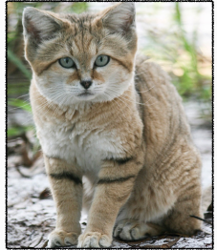 To consider sending these cats to America, so as not to become extinct due to the Gulf War, was a progressive, forward thinking programmatic strategy of the Saudi government. The Saudi government knew it needed to do something to protect this cat native to its area; it created a “programmatic strategy that encapsulated a new way of thinking about the problem” (LaPiana, 2008, p. 28). The problem the Saudi government solved? Ensuring that the sand cat would not become extinct due to the Gulf War.
Another area that BCR does as a nonprofit, is that of edcuation. Educating those who come for a tour, who attend workshops, but also, educating the volunteers that donate their time and energy to BCR. The volunteer program at BCR is extensive and provides different levels of progression to the next level based on time spent at the sanctuary and passing different levels of exams and/or certifications. As an overview, the following is from communication with Carole Baskin of December 16, 2014. It provides an overview as to what the colors of the T-shirts one sees at BCR and the training it represents.
Volunteers:
- Red: First six months, four hours per week, never alone on property, can help care for small cats.
- Yellow: Next year and a half, six hours per week, can work alone, can care for cats up to the size of a cougar.
- Green: After two years they [volunteers] can apply for Green, work eight hours per week and care for lions, tigers, leopards and jaguars.
- Navy: After six years, they [volunteers] can become Master Keepers, work 16 hours per week and can handle medical issues with vet care team.
Interns:
- Royal Blue: Three months, six days a week, daylight to dark. We [BCR] have five levels, so they can keep coming back for each three month level. Each level comes with new training and responsibilities.
Note: Each level requires classes be taken, passed and all of their coordinators recommend them for promotoion.

Carole Baskin also provided me in-depth information pertaining to the training that volunteers & interns, trainees, keepers & partners, senior keeper & partners, and master keeper must undertake. Ms. Baskin created a clone of the training website that BCR uses, but in order to access it I had to create a gmail account, which I gladly did. (Note – Ms. Baskin removed materials and other information from my viewing that was not pertinent to this project). The listing is extensive and impressive. Under Orientation, there are five different levels a volunteer must progress through. Under Trainee, there are eight different levels; under Keeper & Partner, 15 different levels; under Senior Keeper & Partner, seven levels; and, under Master Keeper one level. There are also 24 video classes in addition to the above training levels. Another video that Lisa Shaw mentions is one that “management strongly encourages all who either work or volunteer their time to learn as much as we could about the plight of all wild animals as well as what happens to animals everywhere (http://www.imdb.com/title/tt0775452) not an easy film to watch, it still haunts me” (L. A. Shaw, personal communication, December 29, 2014).
BCR has partnered with Tampa Bay Times Newspaper in Education Program (NIE) in which BCR provided educational workshops for elementary and middle/high school educators. The workshops were held this past September with the highlights of the workshops being “tips for incorporating Common Core State & Next Generation Sunshine State Standards into your lessons; providing in-service points to educators; innovative, cutting-edge teaching ideas; and fresh ideas for NIE activities to help your students love reading” (http://nieonline.com/tbtimes/). The on-site educational tours are year round and the focus is educating students about the animals that live at BCR. The education is provided by walking tours where information shared relates to the cats, how they are endangered, particular facts (such as no two tigers have the same stripes), and how exotic cats do not make nor should be pets. The walking tours expose students to at least 16 species of cats who may be standing only 3-6 feet away. The educational tours are not limited to students, either. Tours for visitors are offered at specific times throughout the day. There are several different tours a visitor can sign up for based on cost. The basic walking visitor tour is rich in information and understanding surrounding the cats. My husband and I have been on this type of tour several times. Interesting facts we learned were about the sand cat (written about above); about the natural habitats of the exotic and wild cats; about how some of the cats came to BCR; and about the white tigers and fraud associated with the in-breeding done to create the white tiger. “All white tigers in the U.S. are crossbred or hybrid animals, part Siberian and part Bengal…every white tiger in the U.S. is not only the result of repeated inbreeding of genetically defective animals, but even worse, is a hybrid or crossbred animal” (Laughlin, 2007, para. 3). Volunteers also learn about the animals at BCR. “We learned to tell people about the animals in our sanctuary and their stories, but, also, to tell them how they can help wild cats. I learned so much – I learned about the legislative process, enrichment, operant conditioning, feeding, medical care, how to build a cage and so much more. I learned how to do it right” (L. A. Shaw, personal communication, December 29, 2014). The educational aspect of BCR working with volunteers, schools, and Tampa Bay Times NIE programs are a great example of an educational strategy that “create[s] competitive advantage where none exists and to strengthen competitive advantage where it does exist” (LaPiana, 2008, p. 32). Besides the volunteer program, BCR also has an internship program and a global internship program. The global internship program, in my opinion, correlates to how it has strengthened its edge. The internship program includes the ability to “host up to 17 interns from around the globe for three month sessions. There is no charge to the intern. BCR provides housing, transportation, food and one night a week of social integration. Between 2012 and September 2014 these benefits provided by Big Cat Rescue to out of state and foreign interns equaled $428,774. BCR provides a value of $6,699.00 per intern, per three month session. Other facilities charge $3,000.00 for the training that BCR provides for free” (Baskin, 2014, p. 1).
BCR was created by its founder, CEO and Board of Directors, Carole Baskin. The nonprofit began in 1992. Currently, there are approximately 80-100 volunteers, 12-17 interns, 14 full time staff, and two contractors. The Board of Directors is made up of Carole Baskin, Howard Baskin (Secretary, Treasurer, and Advisory Board Chairman); Mary Lou Gei; Darren Kipnis; Keith Lawless; Vince Pavese; Kim Mahoney; Pam Rodriguez; and Jamie Veronica (President, Volunteer Committee). Others that help make BCR what it is include Susan Bass (Director of Public Relations); Chelsea Feeny (Project Manager); David L. Ganje, Esquire (Advisory Board); Willow Hecht (Education Director); Gale Ingham (Operations Manager); Jeff Kremer (Director of Donor Appreciation); Jennifer Leon (Education Director); Lynda Licht (Volunteer Committee); La Wanna Mitchell (Webmistress); Katie Nikic (Records Management); Edit Parker (Volunteer Committee); Vernon and Barbara Stairs (Master Builder and Records Management); Honey Wayton (Gift Shop Manager); and, the volunteer vet staff of Dr. Liz Wynn and Dr. Justin Boorstein. The above is from the website of BCR under About Our Staff. An interesting bit of information that I didn’t realize is that the vets can do most of the dental needs for the cats; however, if it is beyond their level of expertize, a dentist who specializes in big cats, Dr. Peak is called in. When I was communicating with Carole Baskin, I asked her if a dentist was requried were the services volunteered. Her reply to me was “I never know if I am going to get a bill or not. Sometimes they do, and sometimes they don’t” (C. Baskin, personal communication, December 15, 2014).
As previously noted, BCR started in 1992, and became a “nonprofit 501(c)(3) organization in 1995 and tax exempt in 1996” (http://www.charitynavigator.org/). Financially, BCR displays their financial information on their website. I asked Ms. Baskin for the 2014 financials, but she stated those figures should be available in April of 2015. She went on further to state that she gets an annual report out in Janauary of each year, but the financials aren’t available until the taxes have been done and audited. Ms. Baskin also mentioned that for 2014 the revenues appear to be $300,000.00 ahead of 2013 due to some bequests provided to BCR. From the financials, their largest revenue source, outside of grants, is from the Educational Tours and Activities, the Gift Shop, and Investment Income. Below is a snag it from the web page http://bigcatrescue.org/about/finances/ which reflects a summary of their audited financial statements from 2009-2013. 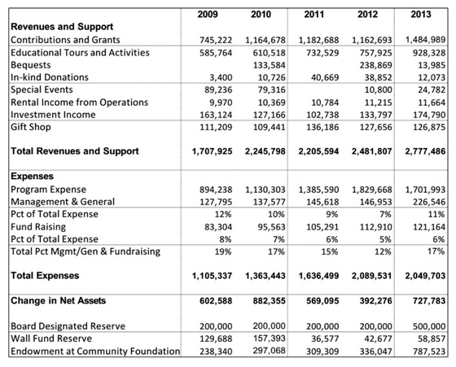 I would like to point out a question I asked Ms. Baskin, which was about the donations that BCR receives, and I had heard that ~90% were used for the cats and 10% for the adminstrative costs. In my opinion, a large reason for the 90% figure was due to the number of volunteers that donate their time to BCR. Ms. Baskin’s response “100% of our donations are used for the cats because our tour revenue and gift shop revenue covers all our administrative costs. We are so proud of this that it is displayed on every page of our website on the right hand bar under the Charity Navigator emblem” (C. Baskin, personal communication, December 15, 2014). There are thousands of people who visit the sanctuary every year. It is interesting to note that according to their website, BCR visitors mainly are from word of mouth. They began a concentrated effort to educate the public in 1998 as they believe they can “save more cats by educating people about not getting them as pets and not supporting activities that they may not realize lead to abuse. So, attracting visitors to our educational tours has become a major part of our mission” (http://bigcatrescue.org/about/finances/). The demographics of the number of visitors from incorporation date of 1995 through 2013 is shown below. (This is from this website http://bigcatrescue.org/about/finances/).
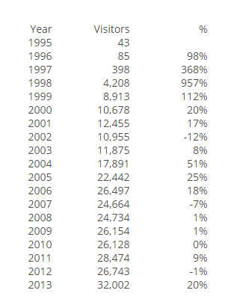
In the 2013 Annual Report of Big Cats Rescue, they have planned for the future of its sanctuary and the cats with an endowment fund. The fund resides at the Community Foundation of Tampa Bay. In the report, it goes on to mention that occasionally, the fund will offer a matching program where the nonprofit, in this case BCR, sets a goal, and when 75% of the goal is reached, the Community Foundation provides the remaining 25%. For 2013, BCR set a goal of $400,000 – which is the maximum allowed. There was a requirement to reach their 75% in three years in order for the Community Foundation to match with 25% ($100,000). Instead of three years, BCR was able to raise the 75% in 9 months, and received the matched $100,000 grant in 2013. BCR is also progressive in thought with the partnership they have with Capital One. To me, this was a great design thinking concept. They have an agreement with Capital One through an affinity card program. “With affinity credit cards, you can show your love for virtually anything…even your favorite charity. ‘Cause’ credit cards automatically donate a portion of each transaction to the charity linked to the card” (Maciejewski, 2008, para. 3). In the case of BCR, 1% of all purchases is donated back to BCR at no cost to the card holder. This partnership speaks to innovative thinking that BCR is doing “it’s critical that the people designing a program consider not only form and function, but distribution channels as well” (Brown & Wyatt, 2010, Winter, p. 33). Credit cards can be considered a distribution channel to be used. Personally, my husband and I use our Capital One card for most purchases we do monthly, and then pay if off monthly instead of using our bank’s debit card.
The current rating of BCR provided by Charity Navigator is an overall 95.17%, which is made up of a Financial rating of 93.17% and an Accountability and Transparency (A&T) rating of 100%. Based on Charity Navigator (CN), the calculation provided is made up of “two distinct components – (1) Financial Health + (2) Accountability and Transparency – in such a way that charities must excel in both areas to score well overall. In the CN system the overall score is not a sum, but rather a measurement of the distance of two component scores from the theoretically perfect score of 100 and 100. The smaller the distance to the perfect score, the better the overall score. Mathematically, the formula used to calculate the overall score is 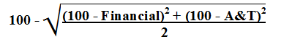” (http://www.charitynavigator.org/). In designing the two dimensional rating system, CN goal was to create a fair rating system that would help would be donors ascertain charities that presented a low risk social investment. Charity Navigator’s mission is to “guide intelligent giving” and it is a “501 (c)(3) nonprofit organization that does not accept any contributions from any charities we evaluate” (http://www.charitynavigator.org/). A geographical reflection of the contributions and expenses breakdown for BCR for 2013 provided by the Charity Navigator organization is shown below. It truly reflects that most costs incurred go directly to the program itself.
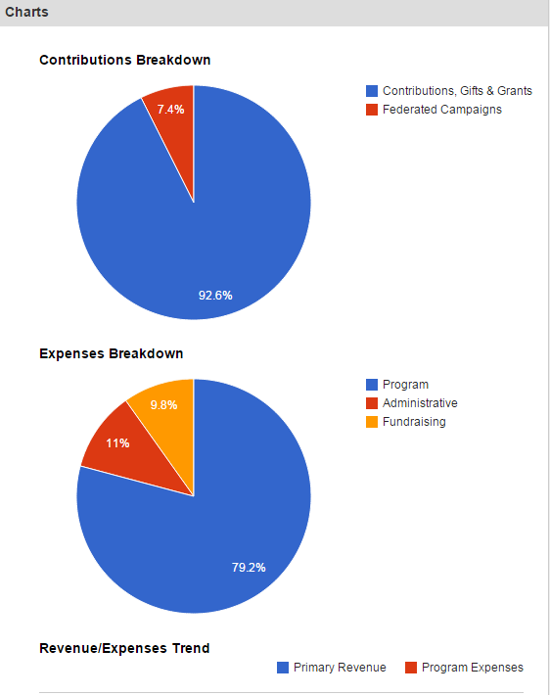
BCR resides on approximately 67 acres in Tampa. In 2008, an article in the Tampa Tribune discussed how BCR cats had been hit by paintballs from teenagers and BCR was trying to raise enough money to “intall a 10-foot wall around the sanctuary’s property…the refuge [of] 45 acres” (Geary, 2008). At that time, BCR only owned 45 acres. Throughout the following years, BCR was able to purchase other out-parcels next to the sanctuary; and, in December of 2013, BCR closed on the sale of an additional 9 acres of land, bringing the total amount of land for the sanctuary to 67 acres. The snag it below reflects the 65 acres owned by BCR for the sanctuary. Citing reference is (http://bigcatrescue.org/). (Areas bounded in dark black and in color).
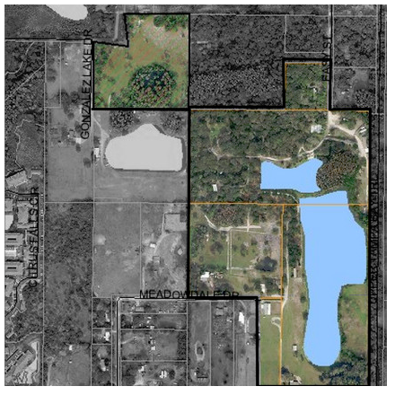
BCR is currently raising funds to purchase other out-parcels to provide a larger area for the sanctuary and the cats.
Big Cat Rescue is a nonprofit corporation in the State of Florida. It became a “corporation in August of 2003 and currently operates as a Florida Nonprofit Corporation. [BCR’s] document number is N03000007047 and its FEI/EIN Number is 593330495 and its current status is active” (http://search.sunbiz.org/Inquiry/CorporationSearch/). As a nonprofit, BCR’s owner, Carole Baskin, is actively involved with legislative issues that surround ending the trade in big cats with a three prong approach – which includes “federal bills, HR1998 - S1381; rescinding the generic tiger loophole with [U.S. Fish & Wildlife Service] USFWS and petitioning USDA to enforce the animal welfare act” (C. Baskin, personal communication, December 15, 2014). Her legislative involvement have made her the target of some individuals who exploit and abuse animals. From Carole’s email to me on December 15, 2014, explaining this three prong approach, I offer her words below.
Regarding the generic tiger loophole: The generic tiger loophole was created in 1998 by the US Fish & Wildlife Service because so many people were breeding white tigers, which are not purebred. The loophole said that if the tiger is not purebred, it's not a tiger, and you don't have to meet the criteria necessary for a permit to breed, like an AZA (Association of Zoos and Aquariums) accredited zoo would. In 2011 the Big Cat Coalition petitioned USFWS to rescind that exemption and they put it on the Federal Register for public contact. More than 13,000 people urged USFWS, in writing to rescind the loophole, but they haven't done anything yet. We've been waiting 3 years.

Regarding the USDA: We petitioned USDA to stop the cub handling. Back in 2011 Big Cat Rescue, the Humane Society of the United States, the International Fund for Animal Welfare, Born Free, the Global Federation of Animal Sanctuaries, the Ian Sommerhalder Foundation and a few others sat down in a room in D.C. to figure out what the source of the big cat crises in America was and how to combat it. The Big Cat Coalition believes that breeding big cats, ripping their cubs away to be used as props and then the way they disappear into the trade is already a violation of the Animal Welfare Act. This 60 page brief was filed with USDA and is currently in the comment period on the Federal Register. As of today 9,688 comments have been posted with the overwhelming majority concurring with our position.

Regarding the federal bill: [The Big Cats and Public Safety Act] Our federal bill has over 115 co-sponsors in the House and 6 in the Senate. The bill will die at the end of this month, but we are gearing up to have it re introduced next year.
In reference to the Florida Wildlife Conservation Commission (FWCC), a movement has been ongoing to end big cat abuse by banning public contact with wild animals; and, having the following changes put into place “please change rule 68A-6.0023 (2) (b) by striking except for contacts as authorized under sub-section (3) of this rule. Then strike all of sub-section (3). At sub-section (4) change ‘injury to’ to ‘contact with’. There is so much more the FWCC should do to protect wild animals, but stopping the abuse of baby wild animals who are used as a pay to play props is the first small step that should be taken in that direction, and has the most far reaching impact when it comes to limiting the number of wild animals who end up being warehoused or discarded when they grow up” (https://www.votervoice.net/BCR/Campaigns/37754/Respond).
In my opinion, the legislative causes will remain an on-going issue for Carole and for BCR. Equally as important, though, are ensuring revenues for the continuation of the care of the cats, providing educational opportunities to the community, and expansion of the sanctuary through purchase of surrounding land. I think BCR does have a sound and ever changing strategic approach to their organization. “Sound strategic thinking can ….help a successful [nonprofit organization] avoid unseen pitfalls and move toward even greater ability to serve its mission” (LaPiana, 2008, p. 113). On the BCR website, under credentials, a listing of the affliations is shown, and those affliations are global in nature. It is affiliated with organizations like Global Federation of Animal Sanctuaries (GFAS); Captive Wild Animal Protection Coalition 2009 Taskforce; Combined Federal Campaign #10766 – since 2008; International Tiger Coalition; Species Survival Network; World Society for the Protection of Animals; No More Homeless Pets of Hillsborough County (founding member); Big Cat Coalition since July 2011 (other members include International Fund for Animal Welfare, Humane Society, World Wide Life; Born Free; Animal Legal Defense Fund; GFAS, and Ian Somerhalder Foundation). BCR also has several area business affiliations – Brandon Chamber of Commerce; Florida Association for the Restoration of Ethics; Greater Clearwater Chamber of Commerce; Greater Tampa Chamber of Commerce; Hillsborough Convention and Visitors Association; Oldsmar/Upper Tampa Bay Chamber of Commerce; St. Petersburg Chamber of Commerce; and Westshore Alliance. Maintaining those affiliations while continuing to pursue legislation that helps to stop the abuse and inbreeding of big and wild cats is important as it provides a strong credential support to the person or organization. “Big Cat Rescue made a conscious decision to end the trade in big cats as pets, props, and for their parts. We have decided to keep our population stable; taking in new cats only as our old ones die of old age, so that we can focus on getting to the root of the matter. The big cat crisis in America is due to the public paying to play with, pose with and see cute cubs on display. If we can stop the glut of big cats who are discarded after they are too old for such use (by the age of 12 weeks according to USDA), then we can end the suffering of more than 98% of the big cats in the U.S. The way to stop is to stop the breeding, outside of ASA accredited zoos. None of the cats in private hands are purebred and thus serve no conservation value. We can’t save tigers in the wild while there is legal smokescreens caused by legal trade in big cats, which provides cover for the illegal trade” (C. Baskin, personal communication, December 15, 2014). Carole’s three-prong strategic approach to legislation is an excellent example of good strategies “formulating good strategies typically involves revisiting fundamental and deeply held beliefs about a company’s [organization] past and future, and people tend not to shift their views without a fight” (Bradley, Dawson, & Montard, 2013 (October), p. 9). Carole and others at BCR fight for these beautiful big cats’ day in and day out by trying to change existing legislation and laws; and, also through education.
BCR and those associated with it need to continue down the path they began and keep pushing forward. Carole relayed to me that her biggest desire is to be put out of business. Now that is a goal! Can you imagine not having a need to protect animals from inbreeding and abuse? Or, not having to protect them from the fur trade or for their parts for supposed medicinal purposes? Carole has done something that Pink discusses in his book, that of story, which makes the understanding of what BCR does and why more definitive in your thoughts and mind. “When facts become so widely available and instantly accessible, each one becomes less valuable. What begins to matter more is the ability to place these facts in context and to deliver them with emotional impact” (Pink, 2005, p. 101). The educational information provided about the big cats, the understanding of how BCR acquired these cats, the remembrance area at BCR that honors all the cats that lived out their life there, the abuse some of these cats took before they came to BCR, all these stories and more provide that deep emotional impact that affects cat lovers hearts. For an example, in the walking tour at BCR, a part of the tour is to show the visitor the size of the cages that housed the big cats before they came to BCR. It is really appalling to see the small sizing – imagine not being able to completely stretch out, or turn around, or sit and not being able to escape touching the side of or top of a cage. Now, consider the size of a lion or tiger or panther or leopard living like that before it came to BCR. Hearing the story and seeing the size of the cages the cats were rescued from prior to arriving to BCR; and, then witnessing how they are housed at BCR, it really does provide that emotional impact that Pink describes. Below is a comparison of sizing of what our State requirements are for a cage, based on the cat, and what BCR provides to the cats in its sanctuary, from the BCR website. 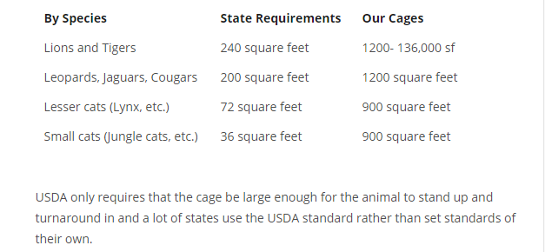BCR, through donations, had been able to complete on the sanctuary grounds a ‘Big Cat and a Little Cat Vacation Rotation’ areas. These larger enclosures allow the big cats and the little cats to spend two weeks in the respective vacation areas and experience a greater area to explore and enjoy. It also provides the cats with different surroundings that they can enjoy while on ‘vacation’. This was an innovative small solution to help the cats from becoming bored. It provided an aspect of wild surroundings for the cats. “Small innovations can be huge…more affordable and produced with less initial outlay; ….be good enough to fulfill an unmet need; ….help minimize environmental effects; ….easier to integrate into the current model with only minor adjustments” (Chakravorti, 2010 (November), p. 106). What BCR found out with the big cat vacation rotation is the transport of the black leopards to the enclosure was a bit difficult seeing as they had no direct connection to the enclosure. The minor adjustment required the leopards being moved closer to the enclosure and erecting and using connecting tunnels, similar to those for the tigers and lions. This minor adjustment decreased the stress the black leopards went through when they had to be transported from their previous cages to the enclosure.
The other aspect of BCR that is so well delivered by the volunteers that provide the educational tours is that of empathy. Not empathy for human to human, but for the cats. Understanding that BCR is providing a sanctuary that provides the cats as close to the environment that they were truly born to be in, as it can, evokes empathetic feelings in all cat lovers. To paraphrase Pink, “empathy is feeling with someone else, sensing what it would be like to be that person [in this case a big cat]” (Pink, 2005, p. 153).
The educational mission of BCR is rich and should be explored more by the organization. Teaming up with the Hillsborough School Board is an excellent start. In 2009, about “40 teachers and administrators visited Big Cat Rescue to learn about the nonprofit organization’s mission and how donations from local schools could benefit” (Pastor, 2009). From this beginning, BCR continues to partner with the schools in providing workshops and other educational opportunities to teach and educate those about their mission and the cats. In my opinion, what BCR is lacking is more mainstream marketing. Unfortunately, there is a cost to advertizing in the papers, online, and on mainstream TV. Having been a life-long resident of Pinellas County, I had never heard of BCR until seven or eight years ago. And, since I consider myself pretty adept at local and current news & events, I think not knowing about BCR shows they could expand and enlarge their marketing for educational opportunities, volunteerism, internships, and visitors. Some further suggestions I would provide to them would be to seek out partnerships with St Petersburg College Veterinary Technology Program, University of Florida undergraduate Veterniary Science and UF’s College of Veterinary Medicine to have students rotate through and learn more hands on with the large array of wild and exotic cats that call BCR home. Another suggestion, would be to have Carole Baskin, or any of the Board, speak at local functions, in schools, at civic meetings, etc. to spread the message. The dual mission of BCR in rescuing exotic and wild cats and educating the public is a strong mission that has been built on a strong strategic plan. BCR knows who it serves, why it serves, how it serves and understands it sources of funding. It is, in my opinion, a strong nonprofit organization that has foresight and is ever morphing to provide more help to the cats and greater education to the public.

References
Animal sanctuary defined. (n.d.). In Wikipedia. Retrieved December 29, 2014, from http://en.wikipedia.org/wiki/Sanctuary
Baskin, C. (2014). 2012-2014 Big Cat Rescue is international in its scope of services for the Combined Federal Campaign [Summary brief]. Retrieved from Combined Federal Campaign Foundation: http://www.cfctoday.org/
Bradley, C., Dawson, A., & Montard, A. (2013 (October)). Mastering the building blocks of strategy. McKinsey Quarterly, 1-12.
Brown, T., & Wyatt, J. (2010, Winter). Design thinking for social innovation. Stanford Social Innovation Review, 31-35.
Chakravorti, B. (2010 November). Finding competitive advantage in adversity. Harvard Business Review, 103-108.
Geary, J. (2008, February 9). Protecting a sanctuary: Big Cat Rescue. The Tampa Tribune. Retrieved from http://tbo.com/news/northwest/2008/feb/09/nw-protecting-a-sanctuary-ar-226399/
Global Federation of Animal Sanctuaries. (2013). Standards for felid sanctuaries [Sanctuary standards]. Retrieved from http://www.sanctuaryfederation.org/gfas/for-sanctuaries/standards/
Guidestar exchange charting impact report [Charting Impact Report]. (2014). Retrieved from http://www.guidestar.org/rxg/update-nonprofit-report/charting-impact.aspx?source=/chartingimpact
LaPiana, D. (2008). The nonprofit strategy revolution. New York, NY: Fieldstone Alliance.
Laughlin, D. C. (2007). White tiger fraud. Retrieved from http://www.dailykos.com/story/2007/08/22/374806/-White-Tiger-Fraud#
Maciejewski, J. (2008). Give more with less through charity credit cards. Retrieved from http://www.creditcards.com/credit-card-news/charity-affinity-credit-cards-1273.php
Pastor, C. C. (2009, April 1). Big Cat Rescue partnering with Hillsborough schools. The Tampa Tribune. Retrieved from http://tbo.com/northwest-tampa/students-raising-money-to-feed-lions-and-tigers-101819
Pink, D. H. (2005). A whole new mind: why right-brainers will rule the future. New York, NY: Riverhead Books.
Sand cat statistics. (n.d.). In Wikipedia. Retrieved December 29, from http://en.wikipedia.org/wiki/Sand_cat
Worksheets
Current Business Model
Scope | Includes | Does Not Include
Geographic Service Area | State of Florida, with particular emphasis on the West Coast districts and Tampa Bay Region | Areas outside of Florida
Customers Served | - Wild and exotic Cats that have been abused, abandoned, given up  - Wild cats that can be rehabilitated to return to the wild  - Schools: Teachers, Students  - Citizens/Visitors  - In 2013, 32,002 people visited BCR | Domestic Cats  Breeders  Sellers  Any creature not a wild or exotic cat
Programs/Services Offered | - Educational Tours  - Volunteer Training  - Internships  - Rehabilitation  - Medical and Dental Care for animals  - Legislative initiatives | Petting zoos  Photo ops with cats  Feeding cats
Funding Sources | - Donations and Contributions  - Grants  - Bequests  - Educational Tours and Activities  - Investment Income  - Gift Shop Income  - Special Events | Sales of Cats

Financial Analysis
Revenue and Support | 2013
Contributions & Grants | 1,484,989
Educational Tours & Activities | 928,328
Bequests | 13,985
In-Kind Donations | 12,073
Special Events | 24,782
Rental Income from Operations | 11,664
Investment Income | 174,790
Gift Shop | 126,875
Total Revenues and Support | 2,777,486
Expenses
Program Expense | 1,701,993
Management & General | 226,546
Percent of Total Expense | 11%
Funding Raising | 121,164
Percent of Total Expense | 6%
Total Percent Management/General & Fundraising | 17%
Total Expenses | 2,049,703
Change in Net Assets
Board Designated Reserve | 500,000
Wall Fund Reserve | 58,857
Endowment at Community Foundation | 787,523
Total Change in Net Assets (Total Revenues & Support – Total Expenses) | 727,783

Trend Analysis
Type of Trends | Direction of Trend | Comments
Demands for program/service due to the following trends:  - Inbreeding of big cats: (Big Cat Coalition petition to USFWS to rescind generic tiger loophole and place on the Federal Register)  - Stop photo op and cub handling (Petition USDA to stop cub handling)  - Ban public contact with wild animals (New effort for Federal Bills HR1998 and S1381)  - Expansion of BCR property – ability to buy more surrounding land | Needs or Demands are:  Increasing for all four trends | All initiatives are a high priority for BCR in the upcoming year. Until illegal trade, buying and breeding exotic and big cats, use of cats parts for medicinal purposes, and abuse are stopped; these trends will continue to occur and rise.  Purchasing more acreage at BCR will allow the sanctuary to increase the number of cats it is able to take in and care for; or rehabilitate to be released back into the wild.
Funding  Contribution & Grants  In-kind Donations  Educational Tours & Activities  Bequests  Special Events  Rental Income from Operations  Investment Income  Gift Shop | Funding continues to be a challenge each year; however, in 2014 BCR received about $300,000 in bequests.  We strive through educational and marketing strategies to increase our funding and/or matching of grants through Community Foundation. | 100% of our operational costs are covered by the tour revenues and gift shop revenues
Other Trends Impacting Organization  Economic Recovery  Reputation  Legislative and Political Activities | As the economic recovery continues, we hope to have more visitors at BCR in the upcoming year.  Our reputation continues to be attacked by those who have money and power that exploit and abuse these magnificent animals.  Our continuation to fight those via legislation and political activities those who do abuse, exploit, in-breed, sell, etc. animals | It is generally recognized the impact that Carole Baskin has had in lobbying and actively working with politicians to change laws and prevent those who are out there exploiting and abusing animals.  BCR is recognized as a global accredited sanctuary and provides its cats as close to what they would have in the wild as possible in their enclosures and in their feed.
Future Business Model
Scope | Includes | Does Not Include
Geographic Service Area | State of Florida, with particular emphasis on the West Coast districts and Tampa Bay Region; expansion to incorporate more of the State of Florida. | Areas outside of Florida
Customers Served | - Wild and exotic Cats that have been abused, abandoned, given up  - Wild cats that can be rehabilitated to return to the wild  - Schools: Teachers, Students  - Citizens/Visitors  - In 2013, 32,002 people visited BCR  Will Consider:  - Tours for Special Need Children  - Tours for Medically Compromised Adults | Domestic Cats  Breeders  Sellers  Any creature not a wild or exotic cat
Programs/Services Offered | Same plus expansion of tours and educational programs.  - Educational Tours  - Volunteer Training  - Internships  - Rehabilitation  - Medical and Dental Care for animals  - Legislative initiatives | Will continue to exclude  Petting zoos  Photo ops with cats  Feeding cats
Funding Sources | - Increased funding from grants and special events.  - Increased awareness of funding needs through the internet, TV, Print, Schools, and word of mouth  - Donations and Contributions  - Grants  - Bequests  - Educational Tours and Activities  - Investment Income  - Gift Shop Income  - Special Events | Sales of Cats
Identity Statement
Components of Identity Statement | Big Cat Rescue Identity Statement
We advance our mission of: | by providing the best permanent home we can for the abused, abandoned, and retired cats in our area. We do this by building enclosures in a very natural habitat with foliage and shelter on our 67 acre site, by providing the best nutritional and medical care possible, and by having active operant conditioning and enrichment programs to provide for the cats physical and psychological well-being.
and seek to: | educate so as to reduce the number of cats that suffer the fate of abandonment and/or abuse and to encourage preservation of habitat and wildlife.
by serving | these cats through rehabilitation and releasing back into the wild; through providing them sanctuary for the rest of their lives at BCR; and, by being actively involved as a member of the International Tiger Coalition, the Captive Wild Animal Protection Coalition, the Global Federation of Animal Sanctuaries, the World Society for the Protection of Animals and others.
In: | the State of Florida, with particular emphasis on the West Coast districts and Tampa Bay Region
through: | being one of the world’s largest accredited sanctuaries for exotic cats; through educational guided tours; through educational programs for young people; and, by maintaining a website that is the world’s largest and best resource for information about exotic cats.
and emphasizing our competitive advantages of | being a leading advocate in ending the abuse of captive big cats and saving wild cats from extinction. In addition to ending the trade in captive big cats, BCR’s goal is to save them in the wild.
We are sustainable by | several diverse sources: grants, an endowment fund with Community Foundation; in-kind donations, Contributions, bequests, investment income, special events, gift shop income, rental income from operations, educational tours and activities, etc.

Charting Impact “(GuideStar Exchange Charting Impact Report last updated 6/10/2014)” (BCR Charting Impact, 2014, p. 3).
Impact Statements | Big Cat Rescue (BCR)
What is BCR aiming to accomplish? | Our goal is to end a need for sanctuaries like ours. We plan to end the trade in exotic cats that causes a need for rescue facilities by educating people about why wild cats belong in the wild and not in cages and by encouraging them to take action to that end by asking for more restrictive laws and not patronizing places that breed wild cats for life in cages.
What are our strategies for making this happen? | We carry out this education through personal guided tours of the sanctuary, a virtual tour app for iPhone and Android and through outreach (that never takes wild animals along as props) and though our online website and social sites.
What are our organization’s capabilities for doing this? | We have the volunteer force necessary to give the daily educational tours and have a full time Education Director who arranges for outreach programs. We have two full time people dedicated to our videos which have received over 79 million views and to answering questions on our social sites. Our website gets 2 million unique visitors per year and has over 9,600 pages of educational content that explains why wild animals belong in the wild and not in our homes and back yard cages.
How will we know if we’re making progress? | We will know that we have achieved our goal when the phone quits ringing with people asking us to take their lions, tigers and other inappropriate pets. We know that the passage of HR199- S1381 the Big Cats and Public Safety Act will eliminate 98% of the breeding and discarding of big cats in this country. Once that bill becomes law there will be a need to shelter the cats who are displaced, but we will see the cats in private hands die out of old age over the next few years and the problem will be solved. We are fortunate to be advocating for a cause that can actually succeed through common sense legislation and better education.
What have and haven’t we accomplished so far? | 2003: The Captive Wildlife Safety Act made it illegal to see a big cat across state lines.  2003-2013: Nine more states have passed bans or partial bans on the private possession of big cats.  2012: The Big Cats and Public Safety Protection Act was introduced and gained 60 bi-partisan co-sponsors before the session ended.  2013: The Big Cats and Public Safety Protection Act we re-introduced and gained 84 bi-partisan co-sponsors by December.  2013: Many countries have also passed bans in this time frame and many countries have passed bans on circus acts that use wild animals. Countless states, counties and cities have passed bans and partial bans and with these bans we are already seeing a huge drop in the number of displaced by cats each year. Dropping from 312 abandoned big cats in 2003 to around 15-20 a year now.
Other Information Attached to Report

GuideStar Exchange Charting Impact Report
Felid Standards July 2013
2013 Audited Financial Statements for Big Cat Rescue

